

**Systems and Database Administration –Journal Entry 2**

**DT211C**

**BSc in Computer Science**

**Tim Browning**

**C14519547**

School of Computing

Dublin Institute of Technology



# Introduction

The objective of this week is to configure and download Oracle software and create a database.

At this point you should have:

* A Virtual Machine
* Oracle Enterprise Linux installed.
* Ram set to 2GB
* Storage set to 35GB
* Users: Root Oracle, TimBrowning
* Network access. I have set my network to manual. IP address is 10.0.2.15
* Network is set to NAT in virtualbox

# Tasks

**1.Customise Hostname**

To check the hostname, enter “*hostname”* in terminal. To change hostname “nano /etc/hosts” and change the hostname to your preference. In my case I changed it to “*tim tim.localdomain”*.

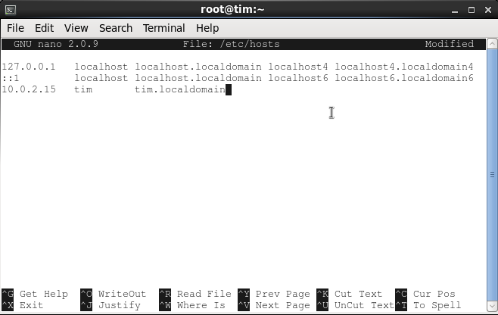

Figure - set hosts

**2.Enabling Guest Additions**

Commands:

* Yum install
* Yum install gcc
* yum install kernel-uek-devel

install guest additions from the 'devices' menu, once the process is finalized, reboot the system.

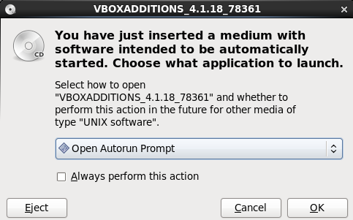

Figure - Guest additions

**3.Downloading from OTN network**

Root account

An account is needed for this step. To download Oracle Database 11g release 2, accept the terms and conditions and click download. There should be two zip files. Place the zip files in the /home/oracle/stage directory. Set permissions to allow oracle to unzip files:

$ chown -R oracle:oinstall /home/oracle/Stage

Oracle account

Unzip the installation files into /home/oracle/stage. This will create a sub-directory called database and it create an installer.

$ Unzip linux.x64_11gR2_database_1of2.zip

$ Unzip linux.x64_11gR2_database_2of2.zip

Root account

Make directory /u01/app and set permissions to allow full access by the oracle user.

mkdir -p /u01/app

chown -R oracle:oinstall /u01

chmod -R 775 /u01/app

**3.Running the installer**

To run the installer, I clicked on the runInstaller button.

Skip the first page as you do not need to enter an Email.

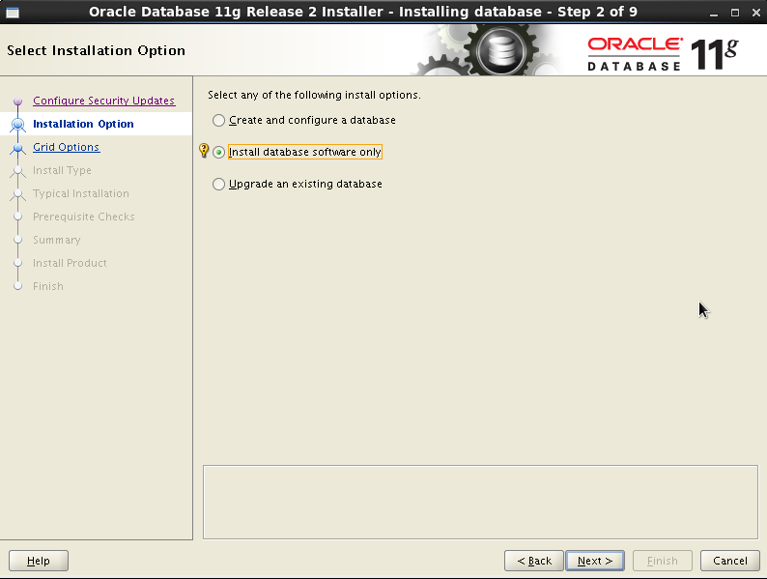

Figure - install software only

The next page asks you for grid options. Select the “*Single instance database installation* “checkbox

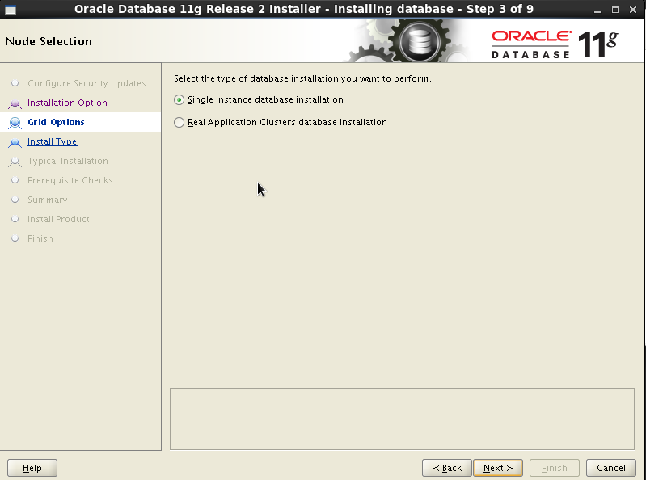

Figure - single instance database

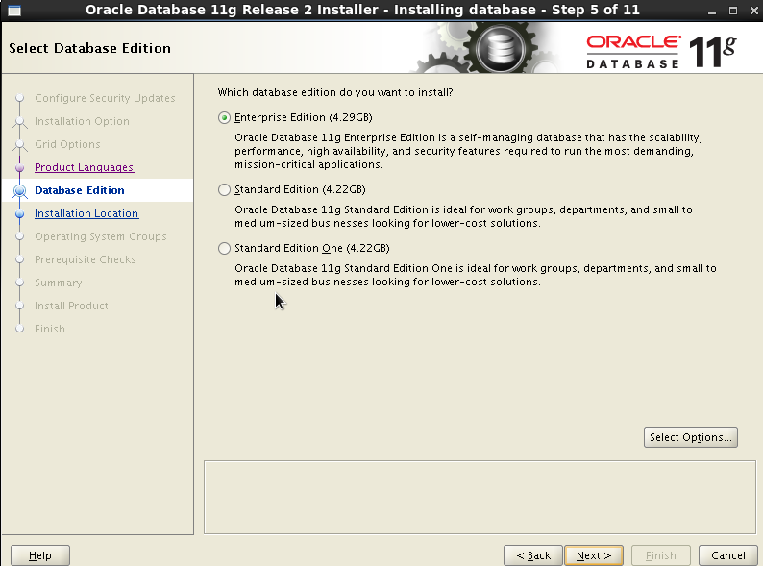

Figure - Enterprise Edition

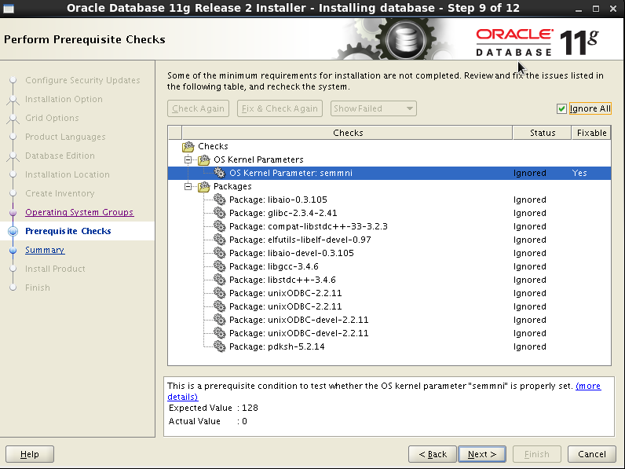

Figure - ignore these errors

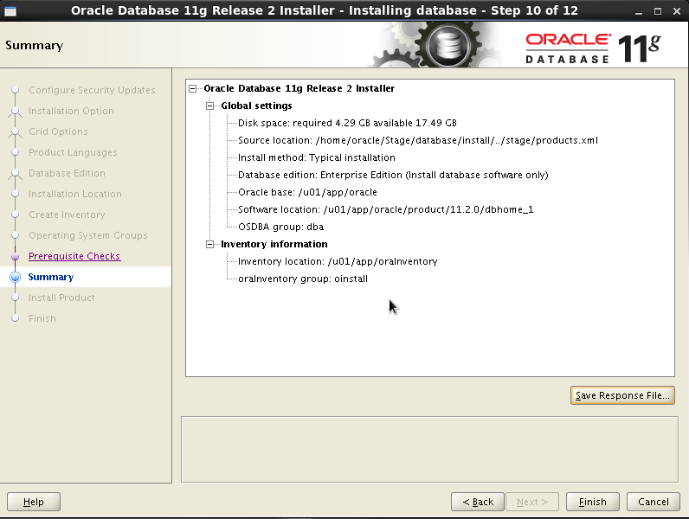

Figure - save the response file

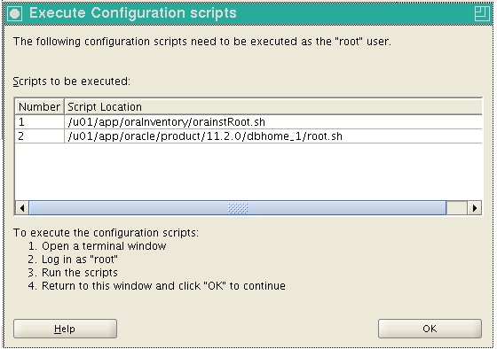

Figure - Enter commands

You will be required to enter two commands as root. To access root open terminal and type su.Enter:/u01/app/oraInventory/orainstRoot.sh AND/u01/app/oracle/product/11.2.0/dbhome_1 /root.sh. Then click ok and your installation is complete.

# Conclusions and Reflections

My installation didn’t come with a listener which meant I couldn’t access the database via the browser. I installed database configuration assistant to fix this problem.

export ORACLE_BASE=/u01/app/oracle/. I put this into my .bash_profile to set the ORACLE_BASE environment variable to define the location of the root of the oracle directory tree. This enabled the configuration assistant to run automatically after the database installed.

The website <https://docs.oracle.com/cd/E26370_01/doc.121/e26358/dbinstall.htm> really helped me as it contained a step by step process. I didn’t follow them exactly as the assignment specified different requirements.